**DAILY ONLINE ACTIVITIES SUMMARY**

|  |  |  |  |  |  |  |  |  |
| --- | --- | --- | --- | --- | --- | --- | --- | --- |
| **Date:** | **21/07/2020** | | | | | **Name:** | **Katira Krishna J** | |
| **Sem & Sec** | **8th A** | | | | | **USN:** | **4AL16CS045** | |
| **Online Test Summary** | | | | | | | | |
| **Subject** | | **-** | | | | | | |
| **Max. Marks** | | **-** | | **Score** | | | **-** | |
| **Certification Course Summary** | | | | | | | | |
| **Course** | **Statistics 101** | | | | | | | |
| **Certificate Provider** | | | **Cognitiveclass.ai** | | **Duration** | | | **6 hours** |
| **Coding Challenges** | | | | | | | | |
| **Problem Statement: Python program to implement bucket sort** | | | | | | | | |
| **Status: Completed** | | | | | | | | |
| **Uploaded the report in Github** | | | | | **Yes** | | | |
| **If yes Repository name** | | | | | **Krishna_Katira** | | | |
| **Uploaded the report in slack** | | | | | **Yes** | | | |

Online Test Details:

No test conducted

Certification Course Details:

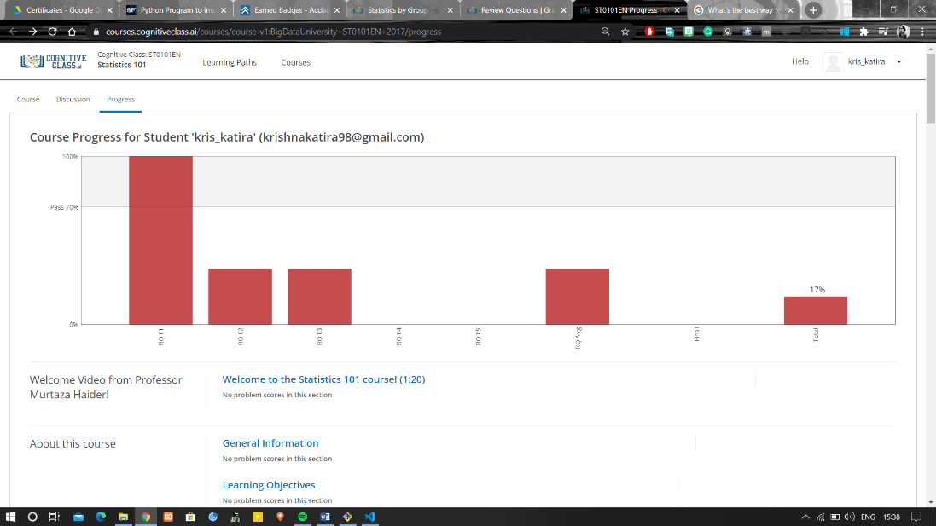

Coding Challenges Details:

**Program:**

def bucket_sort(alist):

largest = max(alist)

length = len(alist)

size = largest/length

buckets = [[] for _ in range(length)]

for i in range(length):

j = int(alist[i]/size)

if j != length:

buckets[j].append(alist[i])

else:

buckets[length - 1].append(alist[i])

for i in range(length):

insertion_sort(buckets[i])

result = []

for i in range(length):

result = result + buckets[i]

return result

def insertion_sort(alist):

for i in range(1, len(alist)):

temp = alist[i]

j = i - 1

while (j >= 0 and temp < alist[j]):

alist[j + 1] = alist[j]

j = j - 1

alist[j + 1] = temp

alist = input('Enter the list of (nonnegative) numbers: ').split()

alist = [int(x) for x in alist]

sorted_list = bucket_sort(alist)

print('Sorted list: ', end='')

print(sorted_list)